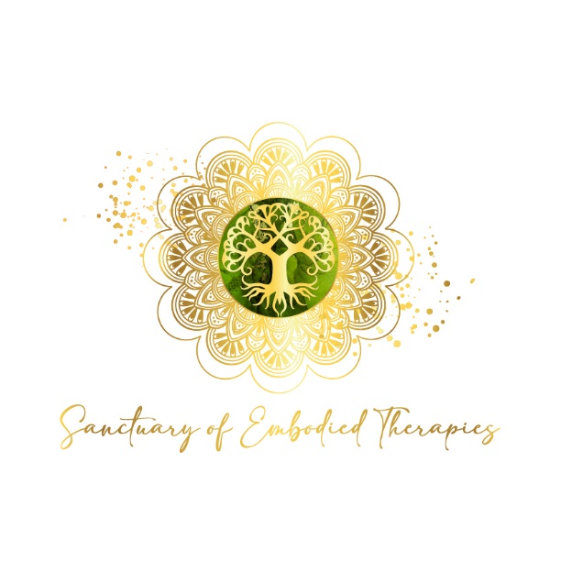
www.suzanneherrity.com

Psychedelic Work: A Trauma-Informed Guide
A complete guide to help you understand, prepare, and stay grounded throughout the process
This guide is intended to support informed choice. It combines what people often wish they had known with a compassionate, parts-aware perspective. You can read it slowly, return to sections, or set it aside if it doesn’t feel relevant right now.

Important Things to Know Upfront
Psychedelics are not a cure. They can open access to thoughts, feelings, memories, or parts of you — but healing happens through preparation, support, and integration, not the substance itself.
- Psychedelics can amplify what is already present, including fear, grief, trauma, or dissociation
- Difficult experiences are often unintegrated material surfacing, not a personal failure
- Insight without support can increase distress or confusion
- The nervous system matters as much as insight or meaning
- More intensity does not equal more healing — gentler experiences are often easier to integrate
- Psychedelics can increase openness and suggestibility, making clear boundaries and ethics essential
- Timing matters — major stress or instability can make the work harder
- Psychedelics do not replace safe, ongoing therapeutic support
- You don’t need psychedelic experiences to heal; relational, paced work can be equally effective

A Trauma-Informed, Parts-Aware Perspective
- Psychedelics don’t heal parts — they may make them more accessible, including vulnerable or younger parts
- Protective parts may soften or lose distance, which can feel exposing
- Some parts may welcome the experience, while others feel unsure or frightened
- Internal boundaries can temporarily blur, especially with dissociation
- What arises is often waiting to be witnessed — not what is “wrong” with you
Healing happens through relationship and attunement, not intensity. Pacing, consent, and presence matter most.

This Work Is More Than the Medicine
Preparation, integration, and relational support are crucial. This includes:
- Learning how your nervous system responds to stress and safety
- Getting to know your internal parts and what helps them feel safe
- Building steadiness and choice before altered-state work
- Making sense of experiences afterwards in a grounded way
This work draws on IFS, Somatic IFS, and nervous-system regulation — it is not just about the medicine.
Resources: Suzanne Herrity - IFS & Medicine Videos

The Process at a Glance

Preparation
- Clarify why you’re interested and what you hope to get from it
- Notice doubts, fears, or mixed feelings — and honor them
- Learn ways to settle and ground your body
- Understand different parts of you and what they need
- Ensure life feels stable enough for deeper work
Nothing should feel rushed. Readiness matters more than timing.

Choosing the Right Support
- Talk openly with a facilitator about their approach
- Ask how they work with fear, overwhelm, or unexpected material
- Clarify boundaries, consent, and aftercare
- Check how your body feels in the interaction
You don’t need to convince yourself. Feeling pressured is a sign to slow down.

Medicine Sessions
- The facilitator supports, not directs or interprets your inner experience
- Sessions are paced according to your system’s readiness
- Focus is on safety, consent, and maintaining connection to Self

Integration Sessions
- Begin after each medicine session
- Goals: process what emerged, support protective or vulnerable parts, restore steadiness, translate insights into everyday life
- Methods: discussion, somatic grounding, journaling, or guided exercises

Ongoing Check-ins
- Observe your parts and body: are they safe, supported, connected?
- Notice overwhelm or bypassing of emotions
- Adjust pacing or support if needed

Adjustments Along the Way
- The process can be slowed, paused, or adjusted at any stage
- Consent, internal safety, and readiness are always the priority
Most healing happens during integration and ongoing support — the medicine itself is only part of the process.

Questions to Ask a Facilitator
Training and ethics: - What training do you have, and what do you not claim to treat? - How do you work with trauma, dissociation, or complex PTSD? - Who supervises or supports your work? - What ethical guidelines do you follow?
Safety and boundaries: - How do you assess readiness? - When would you say no to working with someone? - How do you handle consent before, during, and after sessions? - What are your boundaries around touch, guidance, and suggestion?
Integration: - What support is offered after the experience? - How is ongoing support handled if challenges arise? - Do you collaborate with existing therapists if appropriate?

Red Flags to Notice
Pause or reconsider if you hear: - “The medicine knows best — trust the process” without emphasis on consent - Minimization of trauma, dissociation, or nervous-system needs - Guarantees of transformation or outcomes - Lack of clarity around boundaries, supervision, or accountability

Self-Check
- Do I feel respected and listened to?
- Does my body feel more settled or pressured?
- Am I invited into choice, or compliance?

Final Reminder
You don’t need psychedelic experiences to heal. If you choose to explore them, the most important elements are safety, choice, pacing, and care — for your body, your emotions, and all parts of you.
This guide is for reflection and education only. It is not medical or legal advice.

